

Unique Identification Authority of India
Government of India
Ministry of Communication & IT
Ministry of Electronics and Information Technology (Meity)

User Manual
On
Child Enrolment Lite Client (CELC)


Document version 3.3.5.2
Table of Contents

Introduction 5
Objective 5
Users of CELC 5
Pre-requisites for using the Client 5
About the Client 5
Using the Client 9
Step 1: Child Enrolment Lite Client(CELC) Installation 10
Step 2: Client Registration 10
Step 3: Adding Operator 12
Step 4: Client sync 13
Step 5. Operator Login 14
Step 6 Find Aadhaar 15
Step 7 : Capturing Demographic Information of the child, photograph, document and acknowledgement mobile number 19
iv) Capturing Proof of Relation (POR) document 22
Step 8: Capturing Parent’s Aadhaar 23
Step 9: Review of Enrolment Details and Submission of Proof of Relationship Document 25
Using the Client with BRN/BAN 27
Step 10: Client Settings 29
Mobile Update Steps 34
Step 11. Generate OTP 34
Step 12. Capture Resident Aadhaar and details 35
Step 13: MoU List 36
Step 14: BRN Push……………………………………………………………………………………………………………………………......37
Step 15: Upload Packets……………………………………………………………………………………………………………………..…38
Annexure 1 Device Specification 39
Annexure 2 List of Proof of Relationship (PoR) Documents 41
Annexure 3 List Successfully Tested Tablet, Finger Print Devices for working with CELC 42

Introduction
The current document is the user manual for the Child Enrolment Lite Client. The document elaborates the enrolment process of children below 5 years using this client.

Objective
The objectives of the document are to:
- Explain various features of the Child Enrolment Lite Client
- Explain end to end enrolment process for children below 5 years
- Enable the Operator to easily understand the various functions of the client and operate it
- Enable the Operator to understand the function of the client integrated with Registrar General of India’s (RGI) Civil Registration System (CRS) using Birth Registration Number/ Birth Application Number(BRN/BAN)
- Explain features of FIND AADHAAR.
- Explain feature to Update Mobile/Email.

Users of CELC
- Certified Enrolment Operators/Supervisors
- Certified Operators of Child Enrolment Lite Client

Pre-requisites for using the Client
- Android Tablet as per specification
- Internet connectivity – 2G, 3G, 4G , LTE or Wi-Fi
- Biometric Authentication Devices

About the Client
Background: The Unique Identification Authority of India (UIDAI) was set up as an attached office of Niti Aayog (erstwhile Planning commission) in January, 2009 with a mandate to issue unique identification numbers (Aadhaar) to every resident in the country. The residents are required to undergo the enrolment process for getting Aadhaar. During the Aadhaar enrolment following demographic and biometric information is collected:
Demographic:
- Name
- Date of birth
- Gender
- Address
- Mobile number
- Email (optional)
Biometric:
- Ten fingerprints,
- Photograph
For children under 5 years, Aadhaar number and name of Parent/Guardian (father/mother, guardian) is collected.
The information is collected on an application developed for this purpose called ECMP, i.e. (Enrolment client Multi platform).
Need for a separate enrolment client to enroll children below 5 years:
As per UIDAI’s Child Enrolment policy -in case of children below 5 years of age- the biometric attributes, viz. fingerprint and iris images are not captured, thereby making child enrolment process fairly simple in comparison to that of those above 5 years of age. Keeping this in view a different system of enrolling children below 5 years was conceived which would make enrolment of such children convenient and swift. In line with this, an android based lite enrolment client viz; Child Enrolment Lite Client (CELC), has been developed by UIDAI to enable swift enrolment of children below 5 years. The client will be used to enroll the children by capturing just the photograph and few demographic details in addition to biometric authentication of parents and the operator. Only Proof of Relationship (PoR) document is required to enroll the child. In the current document, we will learn the features of the Child Enrolment Lite Client (CELC) and also, how to use the CELC operations.
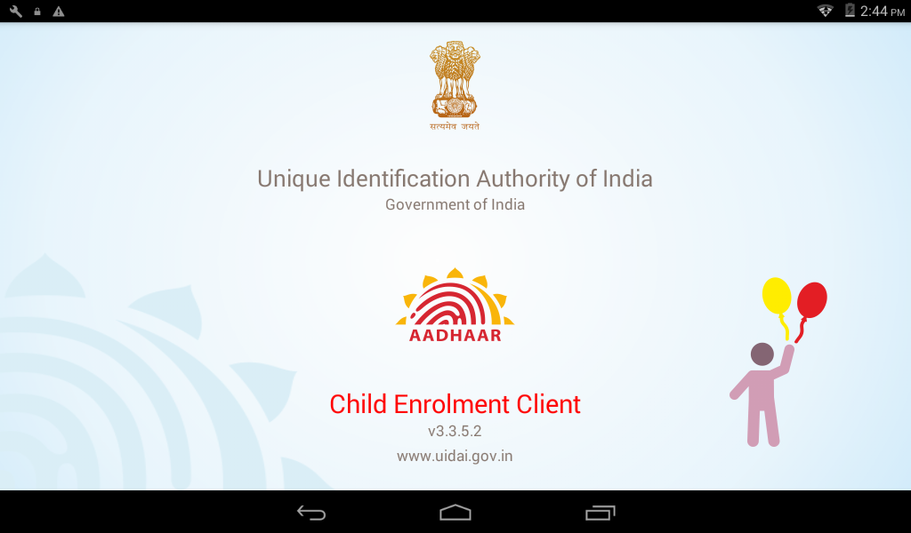

Client Features
Online enrolment: The enrolment is done while the device is connected to the internet through mandatory Edge/ 3G/ 4G mobile data support and Wi-Fi IEEE 802.11b/g/n.
Installed on Portable Devices: The client is installed on handheld tablets for portability.
Instant Operator On-boarding: The online client allows instant addition/activation of the operators.
Real Time Online Biometric Authentication: The Aadhaar based biometric authentication of parents and operators (essential for the enrolment of children on CELC) is done in real time on CELC.
Instant enrolment data upload: The client being connected to internet during the enrolment allows upload of data immediately after an enrolment is complete.
SMS acknowledgement of enrolment: There are no paper acknowledgements given to the enrollee/parent. The SMS acknowledgement is sent on the mobile number captured during the enrolment.
Find Aadhaar: Find Aadhaar is used to find aadhaar number of resident, if resident have forgotten his/her aadhaar number. This can be done using either any one of the ids-EID/UID or few Demographic details.
Mobile Update: A resident can update his/her mobile number with providing mobile number to get otp and show that otp to create request to update the mobile or email-Id by providing biometrics of the resident.
SMS acknowledgement of mobile update: Once the resident requests to update his/her mobile number than SMS is sent to the provided mobile number with generated eid.
CELC Integrated with Birth Registration
This application for enrolling child below 5 years of age is integrated with RGI Server/CRS through an API. Based on Birth Registration Number (BRN)/Birth Application Number (BAN), demo details of child are pulled by CELC Client from RGI Server. The child information is prepopulated in the client & Aadhaar enrolment of a Child is completed. After completing the child enrolment, CELC Client pushes the enrolment number and other details to RGI Server.

Using the Client
Steps in using CELC
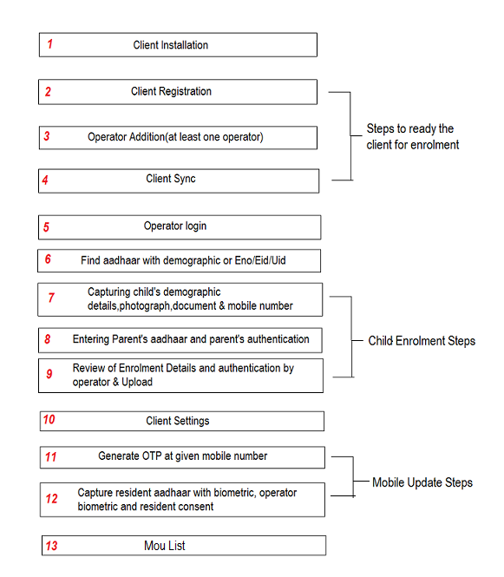
Figure: Steps in using Child Enrolment Lite Client

Step 1: Child Enrolment Lite Client(CELC) Installation
As we know, the Child Enrolment Lite Client runs on an android based tablet. The user needs to install the CELC first on the tablet. For installation please refer to the installation manual. After installation, the user can open the client by tapping on the “Child Enrolment” icon in applications screen of the tablet.

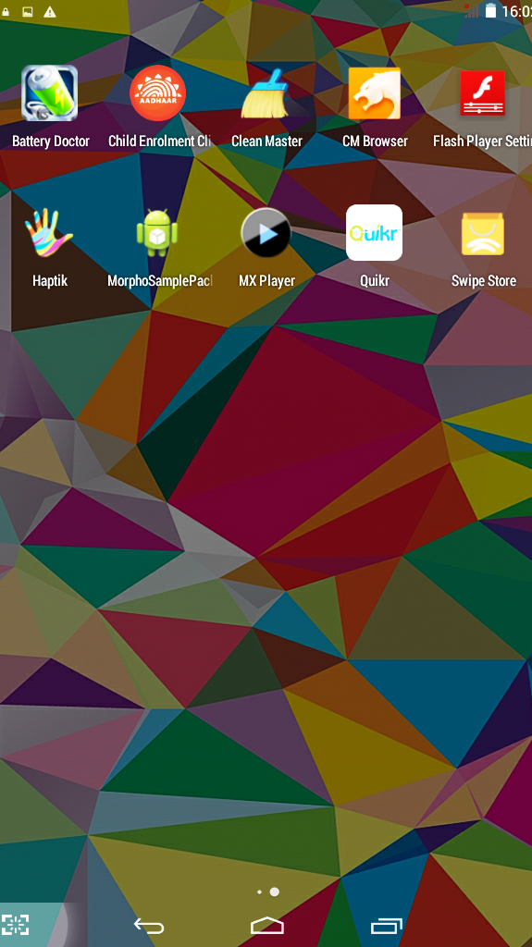
Tap here to open CELC

Let’s now understand the process of making the client ready for enrolment.
Making the CELC ready for enrolment
Step 2: Client registration
Step 3: Adding the operator
Step 4: Client Sync

Step 2: Client Registration
Client registration is a mandatory one-time activity. The process of client registration is as under:
- The first screen that appears upon clicking the CELC icon is client registration screen.
- The user needs to fill the all the fields. These fields are Registrar Code, EA Code, Station ID’s and location ID and admin portal credentials.
- After information is entered in these fields the user needs to tap registration button to register the client. Successful client registration leads the user to ‘Add Operator’ screen. Here at least one operator has got to be added to proceed.
. 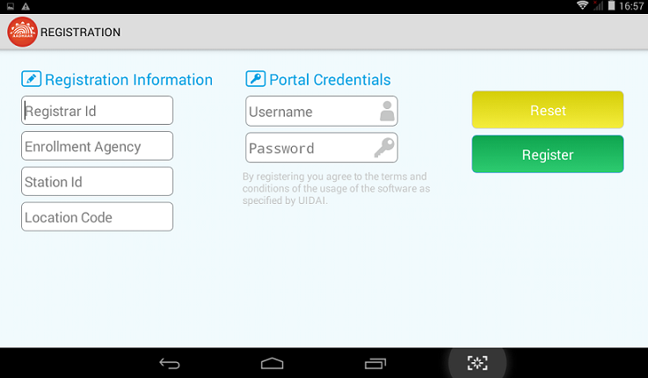
Tap on Register Icon to register the client

Description of various fields of Registration:
Icon | Description
Registrar Code | Registrar Code of the associated Registrar as provided by UIDAI
EA Code | Code of EA who has been assigned the work of enrolment
Station ID | ID of the enrolment station provided by EA.
Location ID | Minimum Six digit Location Id and max to 11 digit provided by EA in consent with Registrar
Admin Portal User name | User name as per the log in credential provided
Admin Portal Password | Password as per the log in credential
Reset | This button is used to reset the information entered in the fields

Step 3: Adding Operator
The next mandatory step is to add the operator(s) in the client. Client will automatically ask to add first operator. As the client is opened after registration, the client automatically takes user to the operator addition page.

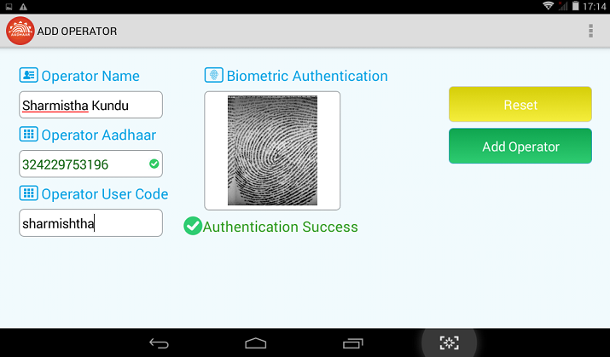
Tap here to add Operator

Fill the required mandatory fields and tap on “Add Operator” button to add operator.
Description of different fields on operator addition page
Field | Description
Name | Name of operator
Operator Aadhaar | UID number (Aadhaar) of operator
Operator user code | Code assigned to operator
Reset | Tap on reset button to reset the fields entered
Authentication Success (Green Colour) | Green colour shows the successful authentication, otherwise authentication failed message will appear in “Red” colour
Green tick mark in | Operator Aadhaar field denotes that the Aadhaar entered is valid, else it will show “X” mark in “Red”

After successful biometric authentication, the user fills in other details i.e. Operator User code, and Operator Name. The user can add more operators by using Operator function on the ‘Home page’ or client settings.

Step 4: Client sync
- On successful addition of the operator, the user is taken to the home screen. On the home screen the user taps on the Settings icon. The Settings login screen is displayed. The operator has to login to the settings area with biometric authentication.
- On successful login the settings/admin area is displayed to the operator, on this screen we can see a Client Sync icon, tap on the icon to display the sync screen and then tap on the Sync Client button to complete the sync.
- After successful sync, the operator has to go back twice to start the enrolment.

Step 5. Operator Login
If the added operator wants to log in the client (in situations explained above) he/she gets the ‘login’ screen after clicking the CELC client on the application screen of the tab.
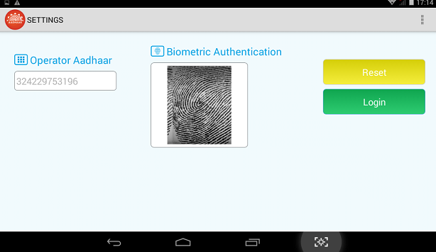
Client Home Page
After the successful log in, the user, lands on the home page of the client.
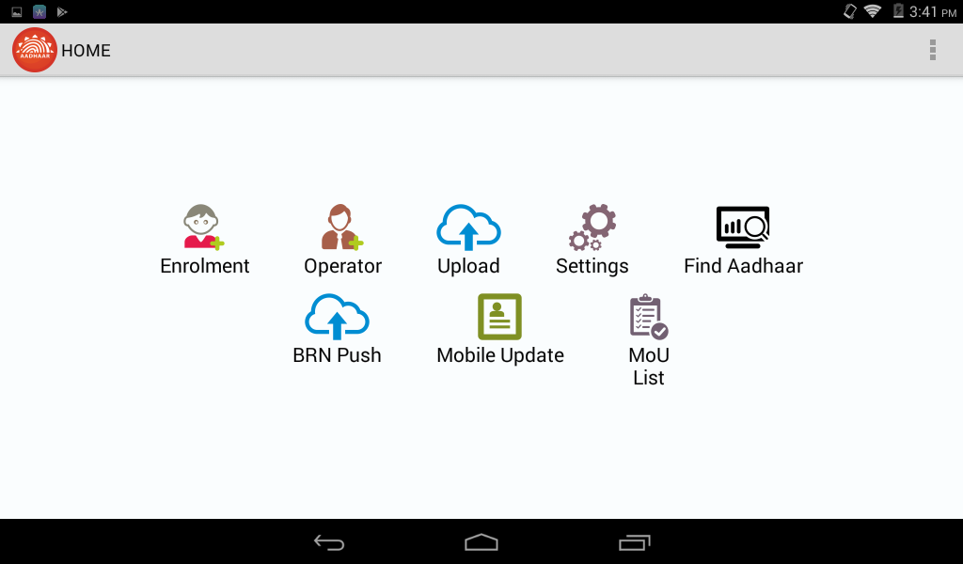

Description of Icons in the Home Page
Icon | Description
Enrolment | User can open the enrolment page by taping on this icon
Operator | This function is used to add the operator in the client.
Upload | This function is used to upload the data and send it to CIDR (UIDAI database) only for those packets which have not been uploaded during enrolment.
Settings | This function is used to perform client settings like Deregistration, Operator addition, deletion and view Operator list, View Enrolment Register and, sync. ‘Setting’ is discussed in details later in this document.
Find Aadhaar | Find Aadhaar is used to find the aadhaar number of resident.
BRN Push | This Function is used to perform push the Enrolment ID to RGI server only for those packets which have not been uploaded during enrolment.
Mobile Update | This link allows the resident to update their mobile number within the aadhaar system.
MoU List | This function is used to show the EID of mobile update.

Step 6: Find Aadhaar
Find Aadhaar is used to find aadhaar number of resident, if resident have forgotten/lost his/her aadhaar number. This can be done using either any one of the ids –EID/UID or few demographic details. Name, District/Pin Code and Gender fields are mandatory demographics to find the aadhaar number of resident. Once the Find Aadhaar button is clicked on the homepage, below page is shown:
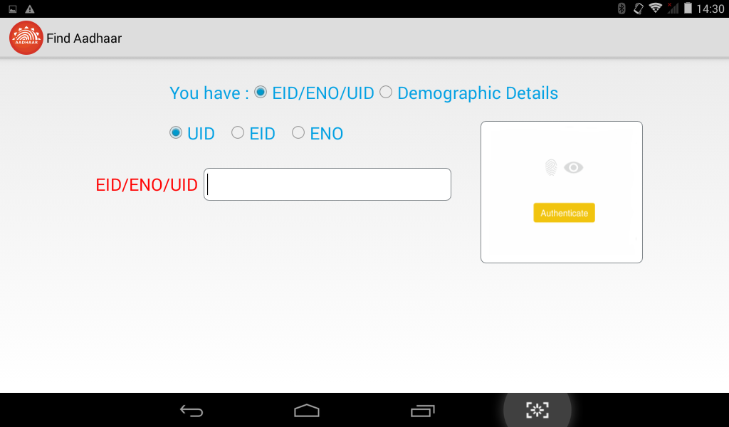

Select one of the following: EIDUID or DEMOGRAPHIC DETAILS.
Where,
EID – Enrolment Id,
UID – Unique Id,

Once the operator selects the Demographic details the following screen appears:

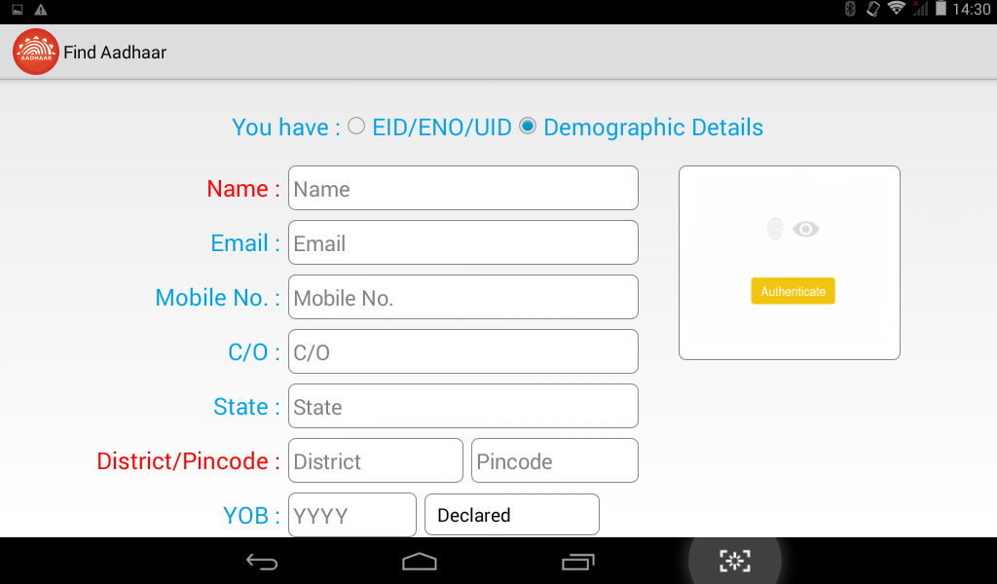

The red colored fields are mandatory.

On choosing EID/UID as the option for Find Aadhaar, below screen is shown:
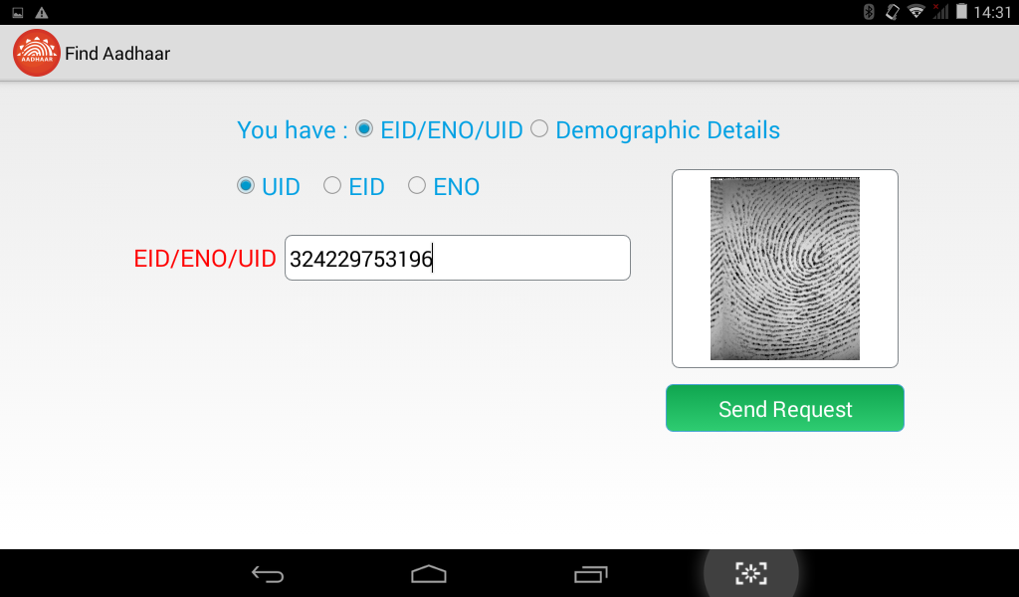

After entering the details, provide Biometrics and press “Send Request”:
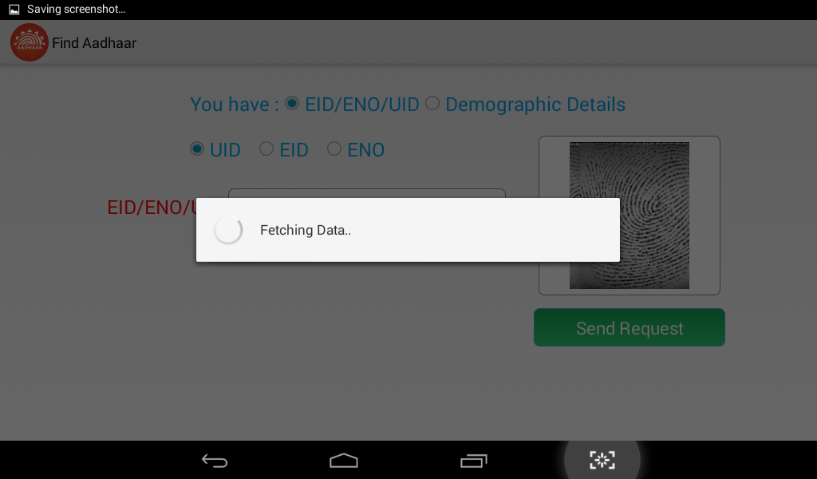
If based on the input query, results are found then the next page shows the details. Details page can be seen with resident photo and other details like name, date of birth, address.

Child Enrolment steps
After the client is registered and operator is added, the client is ready for enrolment. To re-emphasize, the client can only enrol the children below five years.
To initiate enrolment, tap on “Enrolment” icon of the “Home” page.
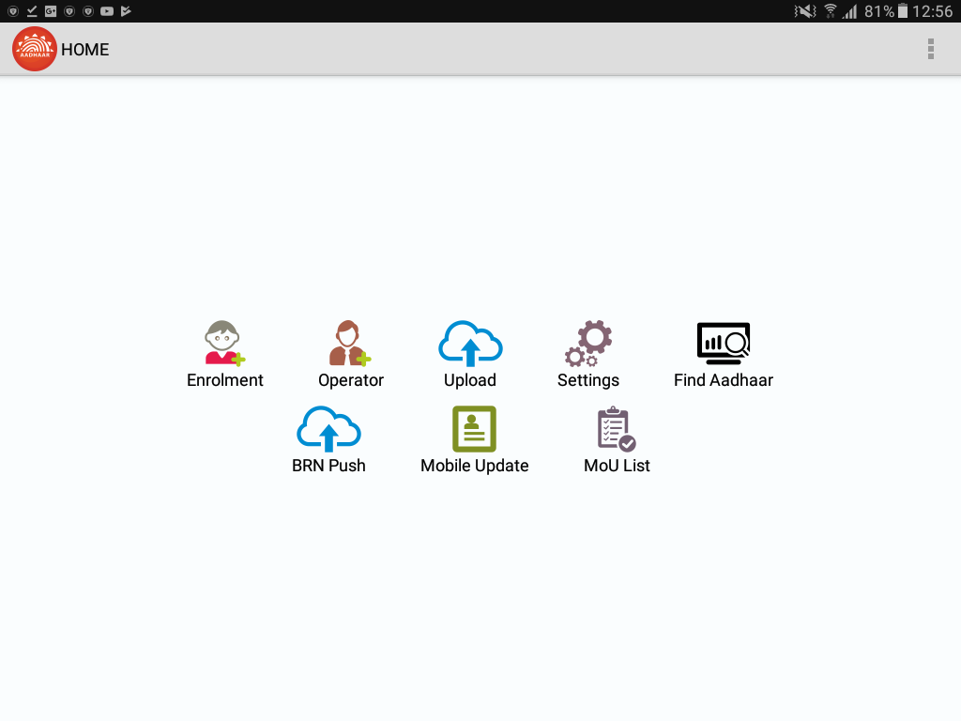
Tap here to open Enrolment page

Taping on “Enrolment” icon, opens enrolment page.
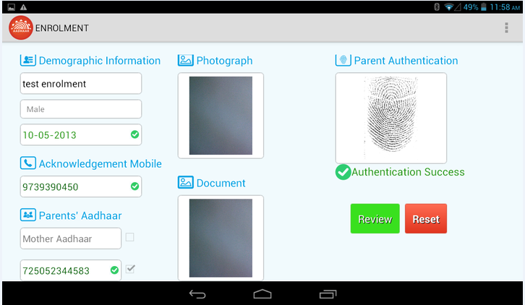

The Enrolment page is further divided into subsections-

Step 7 : Capturing Demographic Information of the child, photograph, document and acknowledgement mobile number
- Demographic Information
Following demographic information of the child needs to be captured:
- Name – Name of the child. The name has to written in full. No salutations such “Ms” etc to be used. In case the child has not been given a name, the name should be captured as “Baby <Number> of<mother’s name>. e.g. “baby <two> of <mother’s name>” and “baby <three> of <mother’s name>” would denote 2nd and 3rd child of the woman (mother) respectively.
- Date of Birth- Date of Birth of child to be chosen from the calendar that pops in.
- Gender- Gender of the child from the dropdown viz. Male, Female and Transgender
ii) Acknowledgement Mobile Capture
Mobile for Enrolment Confirmation- As the print out of the acknowledgement slips are not given to child’s parent, the enrolment acknowledgement information as well as all the status till Aadhaar generation is sent to this mobile number as well as registered mobile (registered mobile number of the parent is the one that is captured during the parent’s enrolment) of the parent whose biometric will be authenticated in the process of enrolment.
NB: In case the child’s parents do not have any mobile number, the operator can enter his/her mobile number and share the acknowledgement details to the child’s parents.
iii) Photograph Capture
This is used to capture the photograph of the child. The camera is auto focus but not auto capture. The operator will have to tap on “Capture Photo” button to capture the photograph.

Guidelines for Facial Image Capture of Child below age 5 years
- Enrollee’s Position: As far as possible Child facial image shall be taken alone. However, for infants, it is acceptable that the child sits on parent’s lap or in supine position, but it needs to be ensured that parent’s face is not captured along with child’s face.

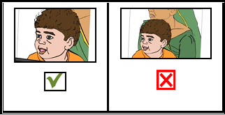

- Adjusting the Camera: It is advised that the Operator should adjust the camera of the tablet instead of changing Enrollee’s position for the right distance and posture. Frontal pose needs to be captured i.e. no head rotation or tilt. Child should be guided to be seat properly with their back upright & their face towards the camera.
- Focus: The capture device should use auto focus and auto-capture functions. The output image should not suffer from motion blur, over or under exposure, unnatural colored lighting, and distortion
- Enrollee’s Expression: Expression strongly affects the performance of automatic face recognition and also affects accurate visual inspection by humans. It is strongly recommended that the face should be captured with neutral (non-smiling) expression, teeth closed, and both eyes open and looking into the camera
- Illumination: Poor illumination has a high impact on the performance of face recognition. The lighting should be such that there are no shadows over the face, no shadows in eye sockets, no shadows under the eye and no hot spots
- Eye Glasses: If the Children normally wear glasses, it is recommended that the photograph be taken with glasses. However, the glasses should be clear and transparent. Dark glasses /tinted glasses should be taken off before taking the photograph.
- Accessories: Use of accessories that cover any region of the face is not permitted. The head may remain covered but the full face contour should be visible. Further, accessories like turban/head gear are also allowed as religious/ traditional practices. Accessories like eye patches are allowed due to medical reasons.
- Manually Capturing the photograph: The camera used is auto focus and not auto capture. The Operator has to click a button in the Child Enrolment Lite Client application software to capture the facial image.
- Picture Quality: Since this client is deployed on tablet, Brightness of photo should also not be focused upon too much because photograph quality might not be as good as that of the one taken through webcam used with ECMP. However, quality of photograph shall be such that the child can be identified from photograph.
- Backdrop: White/plain background for photo should not be mandatory in this case because photograph can be taken at places like nursing homes/house etc.

IV) Capturing Proof of Relation (POR) document
This function is used to capture the proof of relationship document
Select the type of the document you are capturing. POR document can be any of the following: public distribution system (PDS) card/ration card, CGHS/ State Government/ECHS/ESIC Medical card, Army Canteen Card, Passport, Birth Certificate. & any other document prescribed by state/UT govt. as POR, MNREGA Job Card and Pension Card.
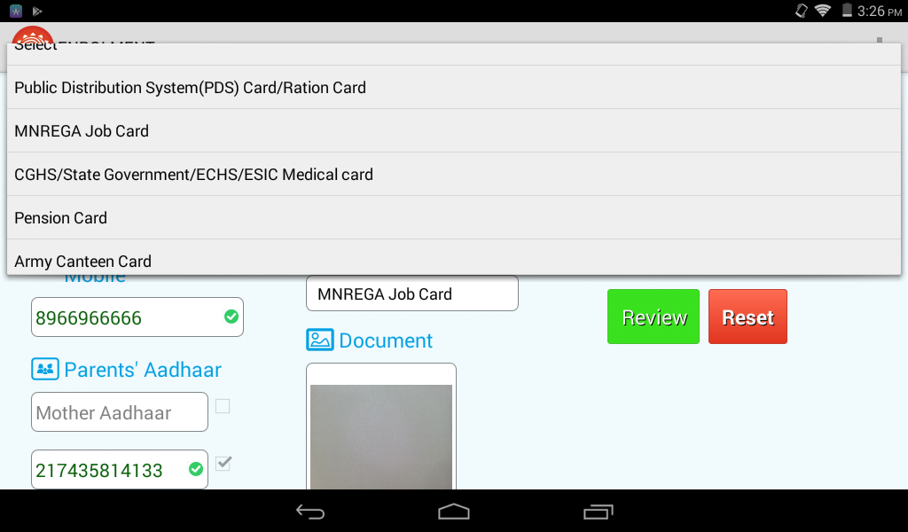
Tapping on the Capture Document button lets you capture the document’s picture.

Step 8: Capturing Parent’s Aadhaar
This subsection captures the Aadhaar/UID number of the parent of the child. There are two fields to capture Aadhaar of mother and father. The Aadhaar of both the parents is to be captured; however, in following situations the capture of one parent’s Aadhaar is also acceptable:
- The child is survived by only one parent
- Only one of the parents’ Aadhaar is generated on the date of enrolment
After Aadhaar entry, selected check box indicates that the biometric authentication for the selected Aadhaar will be performed. Aadhaar of both parents can be entered but authentication will be done against selected checkbox Aadhaar only. To the extent possible authentication of mother’s Aadhaar should be given priority. It should be noted that enrolment of Child through Child Enrolment Lite Client can be done by authenticating parents only. The guardian based enrolment cannot be done through Child Enrolment Lite Client.

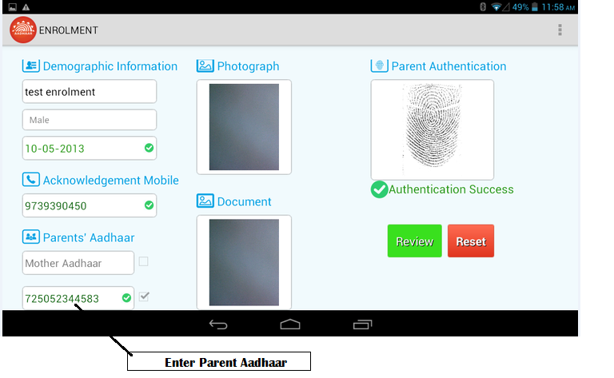

The green color in the field shows the Aadhaar entered is valid. Else, a red “X” mark will be indicated, showing the Aadhaar entered is not a valid Aadhaar.
Parent’s Authentication
This function is used to authenticate the parent of the child. Either of the parents can be authenticated biometrically. Unless the authentication is successful, the next steps in enrolment can’t be performed

Step 9: Review of Enrolment Details and Submission of Proof of Relationship Document
Once capture of all the fields and, photograph along with biometric authentication is complete, tap on “Review” button to go to review page. If the operator/parent finds any mistake in the data entered, it needs to be corrected before proceeding to next step by taping on reset button Tap on the “Review” button to proceed to the review page. The complete data entered during enrolment can be viewed in this window. The operator needs to authenticate himself/herself biometrically to provide sign off to the enrolment.
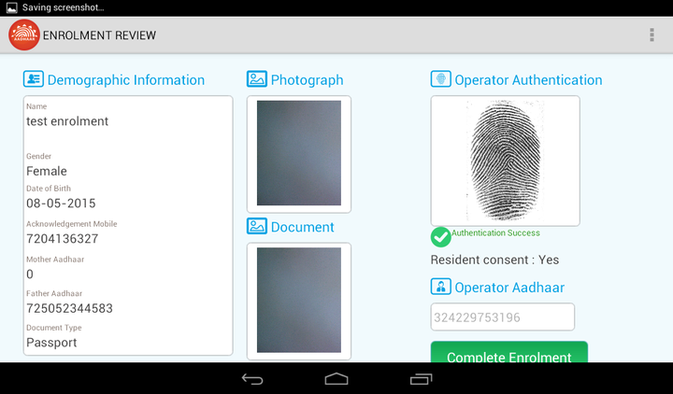
Tap here to complete enrolment

On successful authentication of the operator, taps on “Complete Enrolment” button to complete enrolment. As the enrolment is successfully completed, the data automatically gets transferred to UIDAI database as the enrolment is being done in online environment. A message of successful enrolment appears showing successful transfer of data. In case, data is not transferred, due to reasons like poor connectivity; the operator will have to upload it by using Upload function in Home page.

Parent Consent
Parent consent is taken for use of child enrolment data for Aadhaar generation & authentication. As user clicks on the “Review” button, a dialog box appears asking for the confirmation.

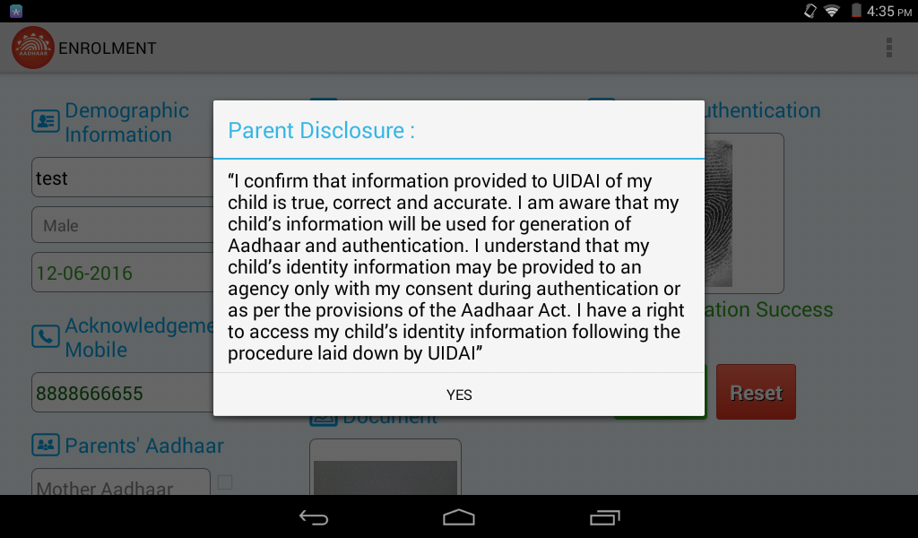

Using the Client with BRN/BAN
CELC Integrated with Birth Registration
Steps followed in the Child enrolment are given below:

In case of Child having BRN/BAN: - There is a text box to enter the BRN/BAN

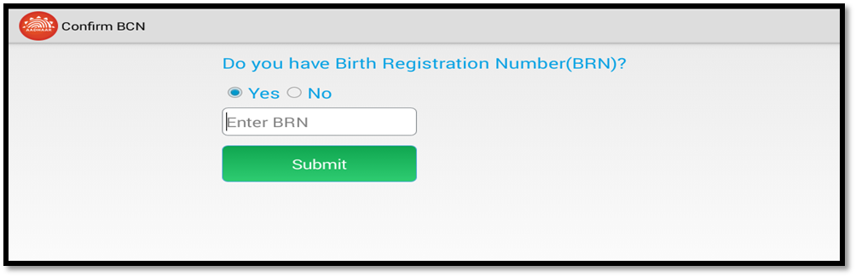

After entering the BRN/BAN number, click on submit.

Client sends the BRN/BAN to the RGI Server which in return provides the below details
- Name of child (Editable)
- DOB (Non editable)
- Gender (Non Editable)

DOB and Gender are mandatory data that is provided by RGI Server, other details like parent’s Aadhaar will be provided by RGI Server only if the data is present.

After the enrolment completion and packet upload process, the EID & other details against the BRN/BAN is pushed to the RGI Server.

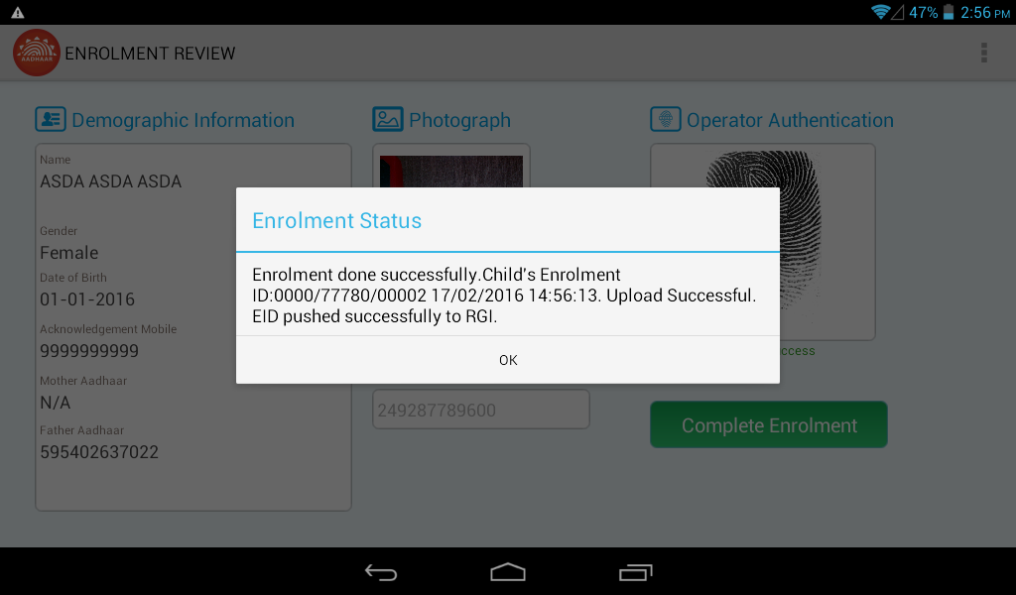

Step 10: Client Settings
The settings option helps to perform various functions, viz., Upload, Enrolment, Operators, Sync and Deregister. The operator has to provide his/her biometrics and authenticate herself/himself first to open the settings page. To access the settings from the Home page, tap on setting button first.
On tapping setting icon, a page opens for operator authentication for which the valid Aadhaar has to be entered and biometric authentication to be provided. Only those operators who have been on- boarded in the client have the permission to perform settings functions.
Tap here to go to settings

On successful authentication, tap on “Settings” button to go to settings page.
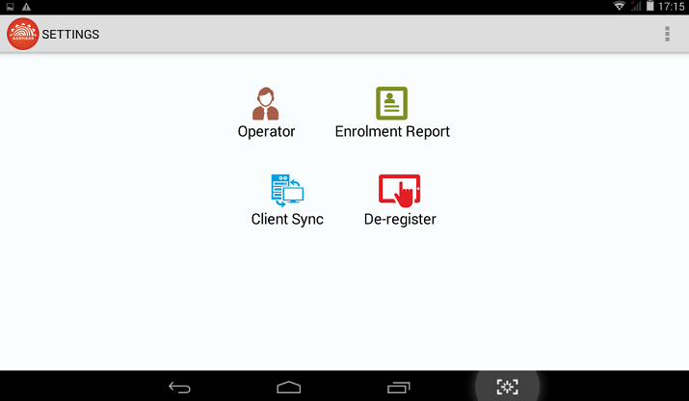

The Settings option lists following functions-
Field | Function
Operator | Add/Delete Operator
Client Sync | Sync the client with UIDAI data base
Enrolment | View enrolment details with upload status
De Register | De register client
Upload | The list of enrolment packets which have to be uploaded

The details of these functions are as under-
Operator
This function is used to add or delete operator in the client. The user needs to select operator in the list and tap on remove button to remove operator. The tick mark shows that the operator is added in the client while the “X” mark shows that the operator has been removed from the client. To add a new operator, the user will tap on the Add Operator button. The Add Operator function opens that enables the user to add operator.

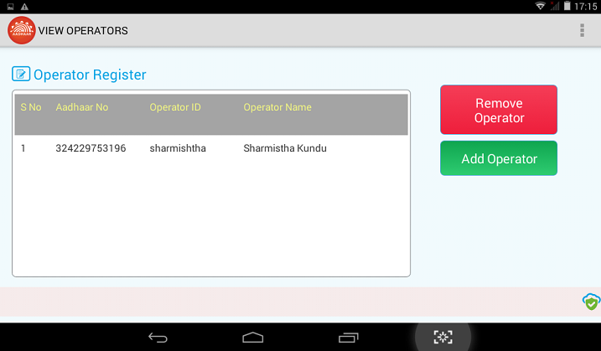
Tap here to add or remove operator Tap here to complete enrolment

Client Sync
This function is used to sync the client at least once in 10 days with UIDAI data base. The page is divided into two sub sections
Sync Information:
This section shows the historical information of sync status about the client. This section shows the number of enrolment packets uploaded and number of enrolment packets synced.
Sync Status:
This section shows the status of number of packets synced and number of packets failed during sync. Tap on “Sync Client” button to sync data.
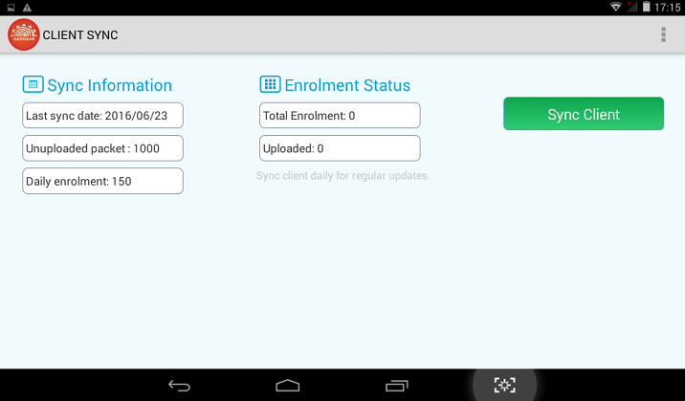
Tap here to sync the client

Client Mandatory Sync Requirements
- Before Start of Enrolment: When the client is registered for the first time and/or the first operator is added, it is mandatory to sync the client first. The client will not allow any operation unless the client is synced first. If the operator tries to open the enrolment page without syncing, a message shall popup asking the operator to sync the client first.
- Every 10 days: It is mandatory to sync the client at least once in every 10-day period. The client will stop enrolments if it is not synced at least once in 10 days.

Enrolments
This section shows the list of enrolments done. This has a sub section “Enrolment Status” shows the name of the person enrolled and their EIDs with the upload status.
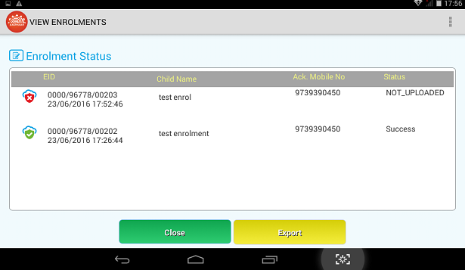
Tap on Export button creates a .csv file into “AADHAAREnrolmentClient” folder created in device storage.
This file stores EID, Child Name, Uploaded, Status and Operator Aadhaar.
Uploaded 1 means successfully uploaded to server whereas 0 means not uploaded to server.
.CSV file is as below.

De Register
This function enables the user to deregister the client. But to use the feature, all the XML packets have to be uploaded & this feature can be used to change location id of the client. This function is used in circumstances such as enrolment is complete or the tablet is to be formatted.
This page has two sections:
Registration Information. This section shows the registration information like Registrar Code, EA code, Station ID
Portal Credentials: The user has to log in by giving user name and password.
Tap on “De Register” button to deregister the client.

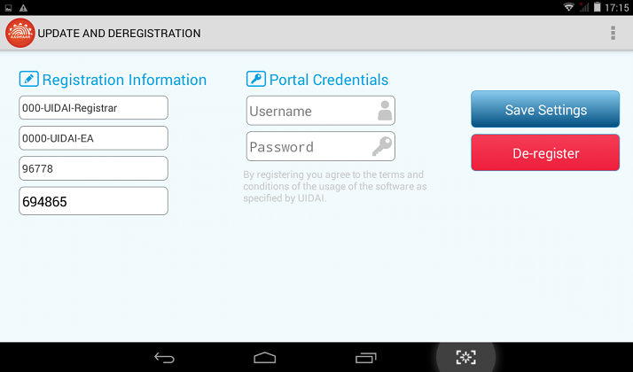

Operator Log Out
The user can log out of the client using the Log Out function. Click on the log out button to log out of the client.
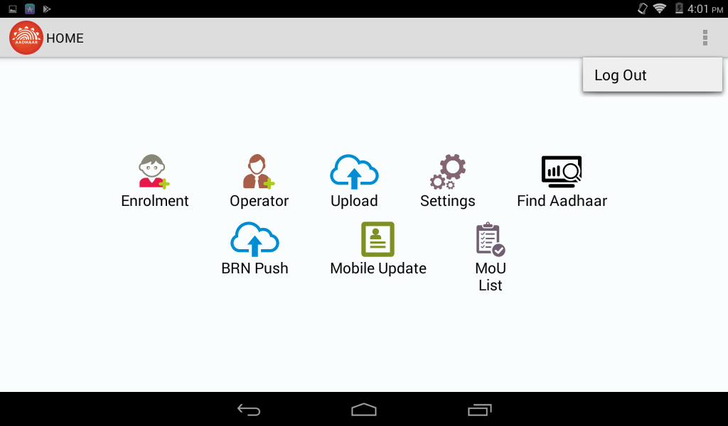

Mobile Update Steps
Mobile update icon provides a convenient mechanism for agencies to offer an easy way for resident to update their mobile number within the Aadhaar system in a secure way using biometric authentication. The link to update mobile number will help residents to update their new mobile number or they can modify their previous mobile number.
On tapping Mobile Update icon, a page opens which loads captcha and asks for new mobile number on which OTP will be send. If captcha is not clear to the user, user can refresh it pressing refresh icon next to Captcha image.

Step 11. Generate OTP

Once the Generate OTP button is clicked user can obtain a verification code by sending OTP code to the new mobile number through SMS and new screen will come to update resident mobile number.

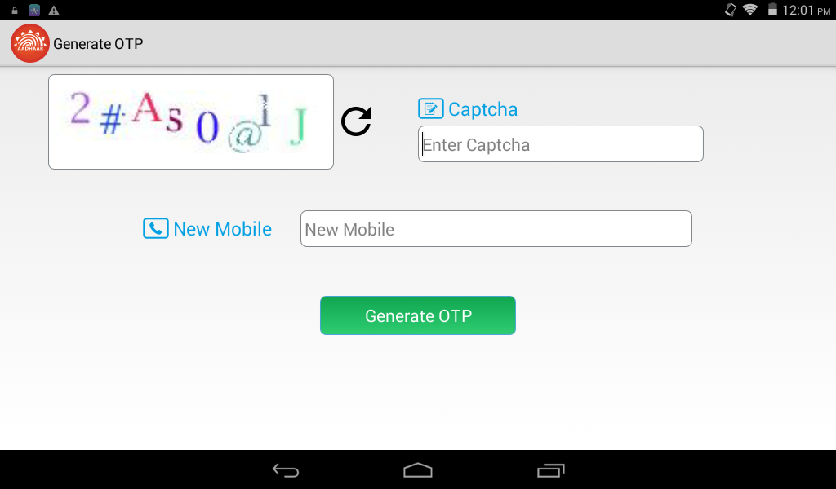
Generate OTP screen

Step 12. Capture Resident Aadhaar and details

New Mobile number on update mobile screen will be non-editable or in read-only mode. Mobile number would be same as provided in the Generate OTP screen.

Once the Resident Disclosure is checked and all the details are filled correctly, Update button is visible. On tapping Update button update request is sent and packet to update user’s mobile number/email id will be generated.

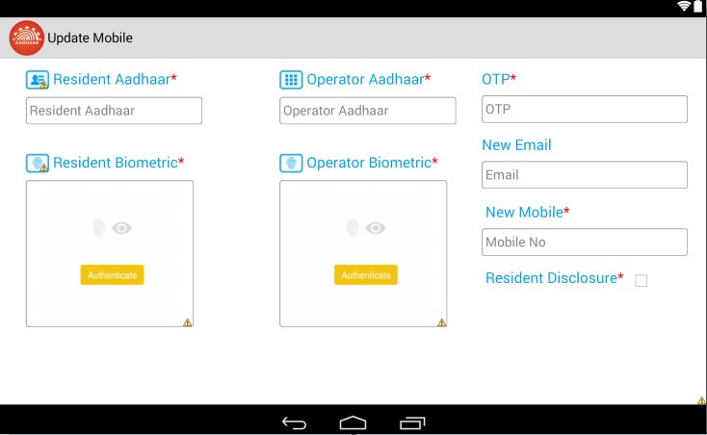
Mobile update screen

Step 13: MoU List
Operator can see the successful mobile update enrollment IDs using the tab. The report will show the top 1000 successful enrollment ID for mobile/email update done from the client/device.
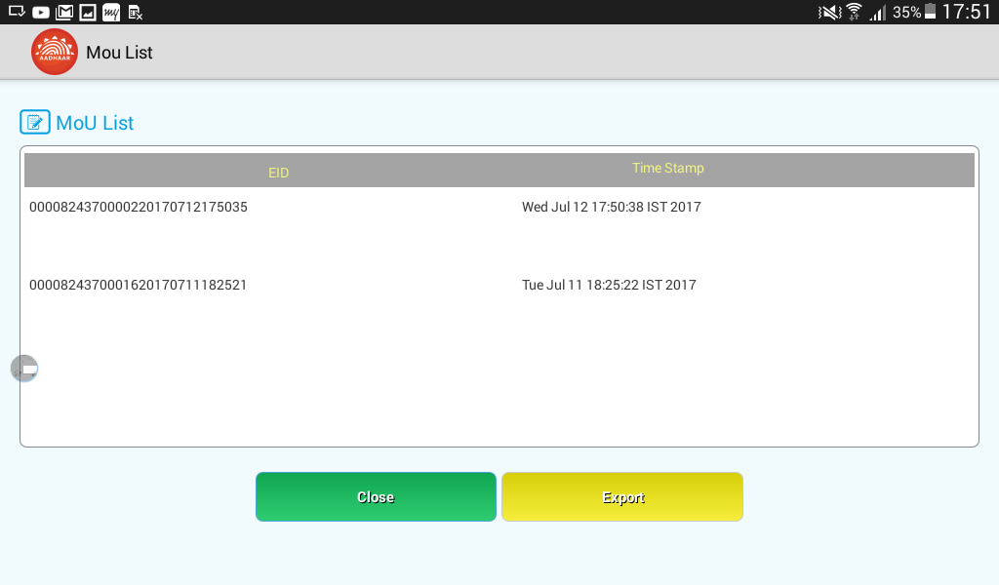

Tap on Export button creates a MoUReport.csv file into “AADHAAREnrolmentClient” folder created in device storage.
This file stores only EID, Child Name.
MoUReport.CSV file is as below.

14. BRN PUSH
This section shows the list of enrolment which is not uploaded to the RGI server at the time of enrolment. This has a sub EIDs with the status icon. Taps on “PUSH” the data automatically gets transferred to RGI database as the enrolment is being done in online environment. A message of successful enrolment appears showing successful transfer of data.
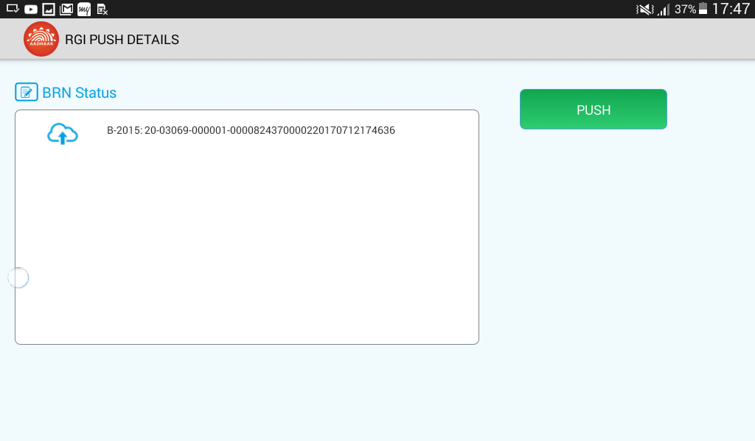

15. Upload Packets
This section shows the list of enrolment which is not uploaded to the server at the time of enrolment. This has a sub EIDs with the status icon. Taps on “Upload” the data automatically gets transferred to UIDAI database as the enrolment is being done in online environment. A message of successful enrolment appears showing successful transfer of data.
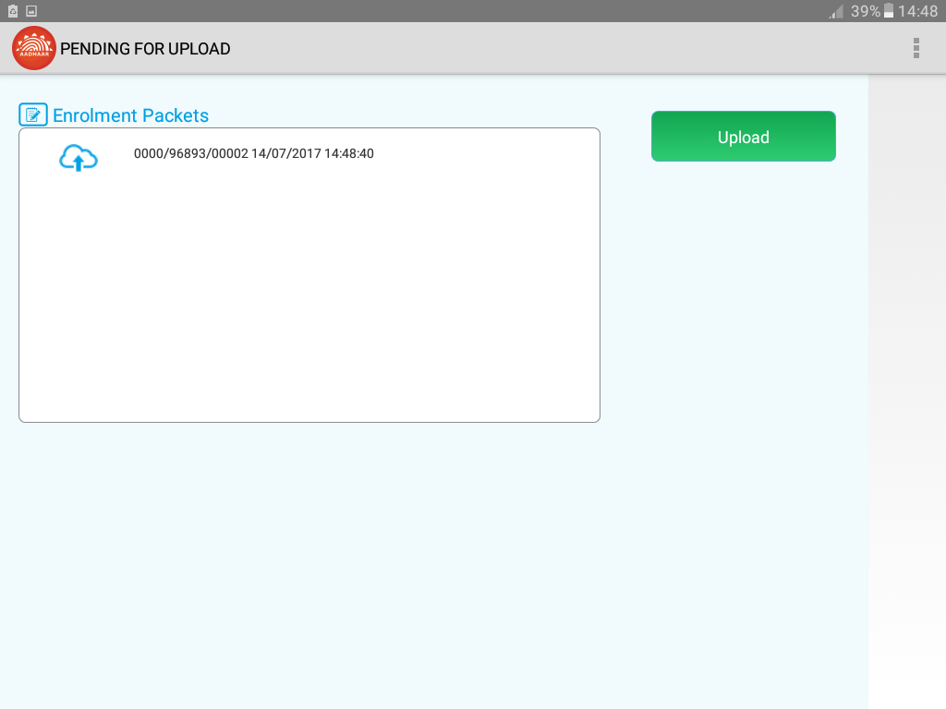

Annexure 1 Device Specification
Android Tablet with 7-inch screen
(Always Check with techsupport@uidai.gov.in for latest requirements).
- Processor- 1.0 GHz Dual Core or above
- RAM- 1 GB or above
- Internal Storage- 8GB or above
- Expandable storage through micro SD, minimum 16 GB
- USB Port- Minimum One Micro USB port and an optional additional USB Port
- USB port should provide power supply to biometric device and support USB OTG.
- Rear Camera with Auto focus & 5 Mega Pixel resolution or above, LED Flash
- 7’’Capacitive touch screen and 1024x600 pixel resolution or above
- Scratch resistant front screen
- GSM SIM card slot
- Min. Battery backup up to 120 minutes, with minimum 3200 mAh battery.
- SAR values within acceptable range
- Separate charging port with AC adapter 110-240-volt range
- Micro USB host cable
- GPS and AGPS facility for capturing the location coordinates
- Connectivity Requirements
- Mandatory Edge/3G/4G/LTE mobile data support
- Wi-Fi IEEE 802.11b/g/n

- Software Requirements for development support
- Android 4.0 Operating System or Above that includes Android 4.1, 4.2, 4.4, 5.0 and 6.0
- Safety and other standards compliance – CE certification/ RoHS certification BIS IS 13252 & FCC certification
- Power Bank for recharging the Tablet (minimum 10000 mAh battery)
Single Fingerprint Scanner Device for use with Android Tablet

- STQC certified Single Finger-print biometric device for Aadhaar Authentication with driver, in-built template extractor software/SDK (mandatorily with license, if required) (STQC Certificate for the device must be submitted)
- API/SDK for Android (4.0 and above) platform.
- Device should be plug and play with any android (4.0 and above) tablet without need of any additional license to be deployed.
- The device should have integrated USB 2.0 type connector.
- Device must come with connector cables to allow connection of the device to Micro USB port
- Sample application for Android platform to test sensor/extractor
- Vendor has to provide all necessary technical support for integration of their device.
Iris Authentication Device for use with Android Tablet

- STQC certified Iris authentication device for Aadhaar Authentication and extractor software/SDK (STQC Certificate must be submitted)
- API/SDK for Android (4.0 or above) Operating System
- Device should be plug and play with any Android (4.0 and above) without need of any additional license to be deployed
- The device should have integrated USB 2.0 type connector.
- Device must come with connector cables to allow connection of the device to Micro USB port
- Sample application for Android platform to test Iris sensor/extractor
- Vendor has to provide all necessary technical support for integration of their device.

Annexure 2 List of Proof of Relationship (PoR) Documents

- Public Distribution System (PDS) Card/Ration Card
- CGHS/State Government/ECHS/ESIC Medical Card
- Army Canteen Card
- Passport
- Birth Certificate issued by Registrar of Birth, Municipal Corporation and other notified local government bodies like Taluk, Tehsil etc.
- Any other Central/State government issued family entitlement document
- MNREGA Job Card.
- Pension Card.

Annexure 3 List Successfully Tested Tablet, Finger Print Devices for working with CELC

Tabs Brand & Model

- Dell M-70CT
- Lenovo Tab 2 A10-70L
- Micromax Canvas Tab P480
- Samsung SM-T116NY (Samsung tab 3)
- Samsung SM-T355Y (GALAXY Tab A)
- iBall Slide
- Forstar FT7Q3
- Forstar FT10Q4
- Lenovo TB-7703X
- Forstar FT8Q4
- Datamini TPOS7

Finger Print Device
- Morpho 1300E, 1300E2, 1300E3
- Mantra MFS100
- StarTek FM220
- bioEnable eNBioScan-C1

